Ansible Task 1
1. What is Ansible?
Ansible is an open-source IT automation tool used to automate server configuration, software installation, application deployment, and system administration.
It helps administrators manage multiple servers from a single control machine without manually logging in to each server.
Example: Instead of installing Apache on two EC2 instances individually, we can use one Ansible command to install it on both servers.
2. Why do we use Ansible?
- Automates repetitive tasks.
- Manages multiple servers from one control node.
- Installs and configures software.
- Starts, stops and restarts services.
- Creates users, groups, files and directories.
- Helps maintain consistent configurations across servers.
- Reduces manual work and human error.
3. Ansible architecture
Ansible uses a control node to communicate with managed nodes.
Control Node — Ansible Master
Ansible installed here
SSH connection and remote execution
Worker 1
Managed node
Worker 2
Managed node
Main components
- Control node: The machine where Ansible is installed and commands are executed.
- Managed nodes: The remote servers managed by Ansible.
- Inventory: A file containing the hosts that Ansible manages.
- Modules: Components that perform tasks such as checking connectivity or managing services.
- Playbooks: YAML files containing a sequence of automation tasks.
- Plugins: Extend Ansible's functionality.
- Facts: Information gathered about managed hosts, such as IP addresses, operating systems and memory.
4. Important features of Ansible
- Agentless: No Ansible agent is normally required on Linux managed nodes.
- SSH-based: Uses SSH for remote Linux server management.
- Simple: Uses readable commands and YAML.
- Idempotent: Many modules can be run repeatedly while maintaining the desired state.
- Automation: Can manage many hosts with one command or playbook.
- Extensible: Supports modules and plugins for different automation tasks.
5. Ansible inventory
An inventory defines which servers Ansible manages. It can contain IP addresses, hostnames, groups and connection variables.
Example inventory for your EC2 lab:
[workers]
worker1 ansible_host=172.31.8.11
worker2 ansible_host=172.31.8.12

[workers:vars]
ansible_user=ubuntu
The IP addresses above are examples; replace them with your actual worker private IPs.
Important terms:
- workers: Group name.
- worker1 and worker2: Inventory hostnames.
- ansible_host: Actual address of each EC2 instance.
- ansible_user: SSH login user for Ubuntu.
6. Ansible ad hoc commands
An ad hoc command is a single command used to perform a quick task on one or more managed nodes without creating a playbook.
Syntax
ansible <host-pattern> -i <inventory-file> -m <module> -a "<arguments>"
Option | Purpose
ansible | Runs Ansible from the command line
all | Targets every host in the inventory
-i | Specifies the inventory file
-m | Specifies the module
-a | Supplies module arguments
-b | Enables privilege escalation, typically sudo
-K | Prompts for the become password
Common examples
# Check connectivity
ansible all -i ansible_hosts -m ping

# Check uptime
ansible all -i ansible_hosts -a "uptime"

# Check memory
ansible all -i ansible_hosts -a "free -m"

# Gather system facts
ansible all -i ansible_hosts -m setup

# Check disk space
ansible all -i ansible_hosts -a "df -h"
7. Ansible modules
Modules are the units of work Ansible executes on managed nodes.
Module | Purpose
ping | Tests Ansible connectivity and Python-based module execution
setup | Gathers system facts
command | Executes a command without shell processing
shell | Executes commands through a shell
file | Manages files, directories and permissions
copy | Copies files to managed nodes
user | Manages user accounts
group | Manages groups
apt | Manages packages on Debian/Ubuntu
service | Manages system services
For example, the file module can create a directory, while the service module can start Apache.
8. Ansible playbooks
A playbook is a YAML file that defines multiple tasks to execute in order.
Example:
---
- name: Install Apache on workers
hosts: workers
become: true

tasks:
- name: Install Apache
apt:
name: apache2
state: present

- name: Start Apache
service:
name: apache2
state: started
enabled: true
Save it as apache.yml and execute:
ansible-playbook -i ansible_hosts apache.yml
Difference: Ad hoc commands are useful for individual tasks, whereas playbooks are suitable for repeatable, multi-step automation.
9. SSH authentication and privilege escalation
- SSH authentication: Allows the control node to connect securely to managed nodes.
- Private key: Must be protected and should never be shared publicly.
- become: true or -b: Runs tasks with elevated privileges, usually as root.
- -K: Prompts for the sudo password when required.
- --ask-pass: Prompts for the SSH login password rather than relying solely on key authentication.
10. Common Ansible commands to remember
# Display Ansible version
ansible --version

# List inventory hosts
ansible all -i ansible_hosts --list-hosts

# Test connectivity
ansible all -i ansible_hosts -m ping

# Gather host information
ansible all -i ansible_hosts -m setup

# Execute a command on all workers
ansible all -i ansible_hosts -a "uptime"

# Run a playbook
ansible-playbook -i ansible_hosts apache.yml
11. Conclusion
Ansible provides a simple way to automate the configuration and management of multiple servers. Its main concepts include the control node, managed nodes, inventory, modules, ad hoc commands and playbooks. SSH provides remote access, and privilege escalation allows authorized administrative tasks to run.

Step 2: Set up one master and two worker nodes in Ansible.
Create an Ansible Master node and 2 worker nodes to connect
Step 1: Copy the key to your Ansible master
Open a new PowerShell window on your Windows PC and run this command. Replace MASTER_PUBLIC_IP with the master's actual public IPv4 address from AWS EC2.
Step 2: Secure the key on the master
Switch to your existing SSH terminal connected to the master and run:
chmod 400 ~/worker-key.pem
ls -l ~/worker-key.pem
Step 3: Test SSH to Worker 1
From the master's Ubuntu terminal, run this command, replacing the example IP with Worker 1's actual private IP:
ssh -i ~/worker-key.pem ubuntu@WORKER1_PRIVATE_IP

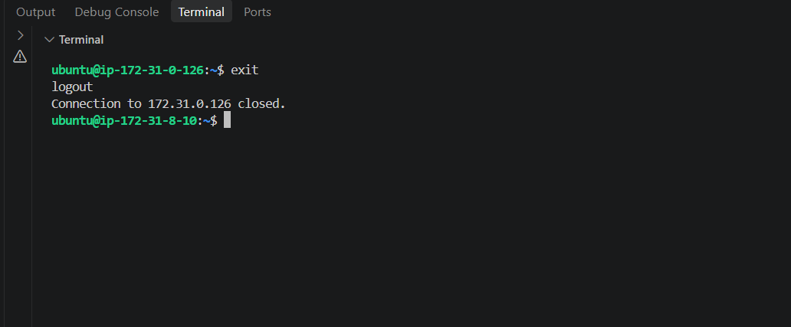
Step 4: Test SSH to Worker 2
ssh -i ~/worker-key.pem ubuntu@WORKER2_PRIVATE_IP
After successful login, return to the master:
exit

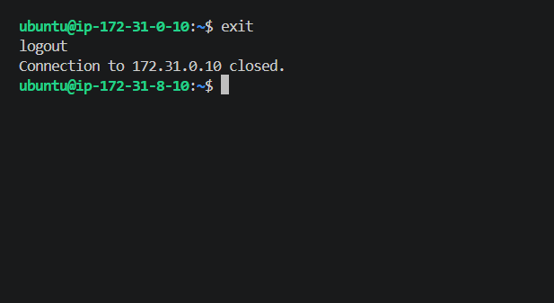
Step 2: Create the Ansible inventory
Once Worker 2 is confirmed, run these commands on the master:
mkdir -p ~/ansible-lab
cd ~/ansible-lab
nano ansible_hosts
Paste this configuration:
[workers]
worker1 ansible_host=172.31.0.126
worker2 ansible_host=172.31.0.10

[workers:vars]
ansible_user=ubuntu
ansible_ssh_private_key_file=/home/ubuntu/worker-key.pem

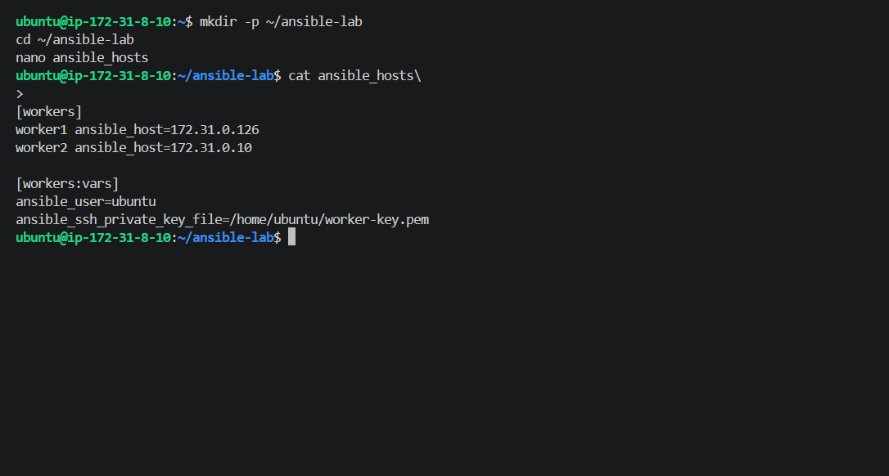

Step 3: Test Ansible connectivity
ansible workers -i ansible_hosts -m ping

Step 1: Run connectivity and system-information commands
You're already in ~/ansible-lab. Execute each command on the master.
1. Check connectivity
Your document contains two variations. Use the inventory-aware command:
ansible all -m ping -i ansible_hosts
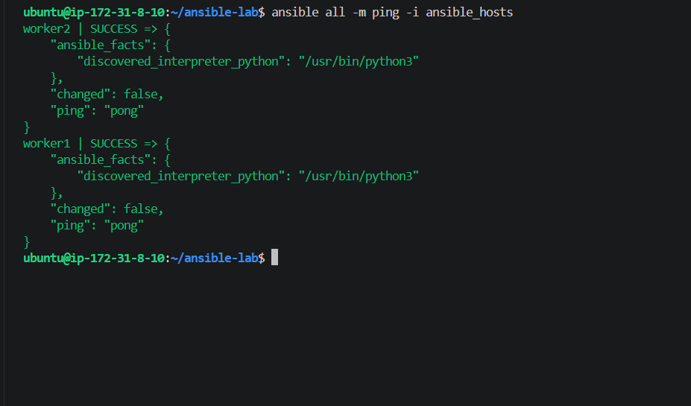
2. Gather facts about both workers
ansible all -i ansible_hosts -m setup
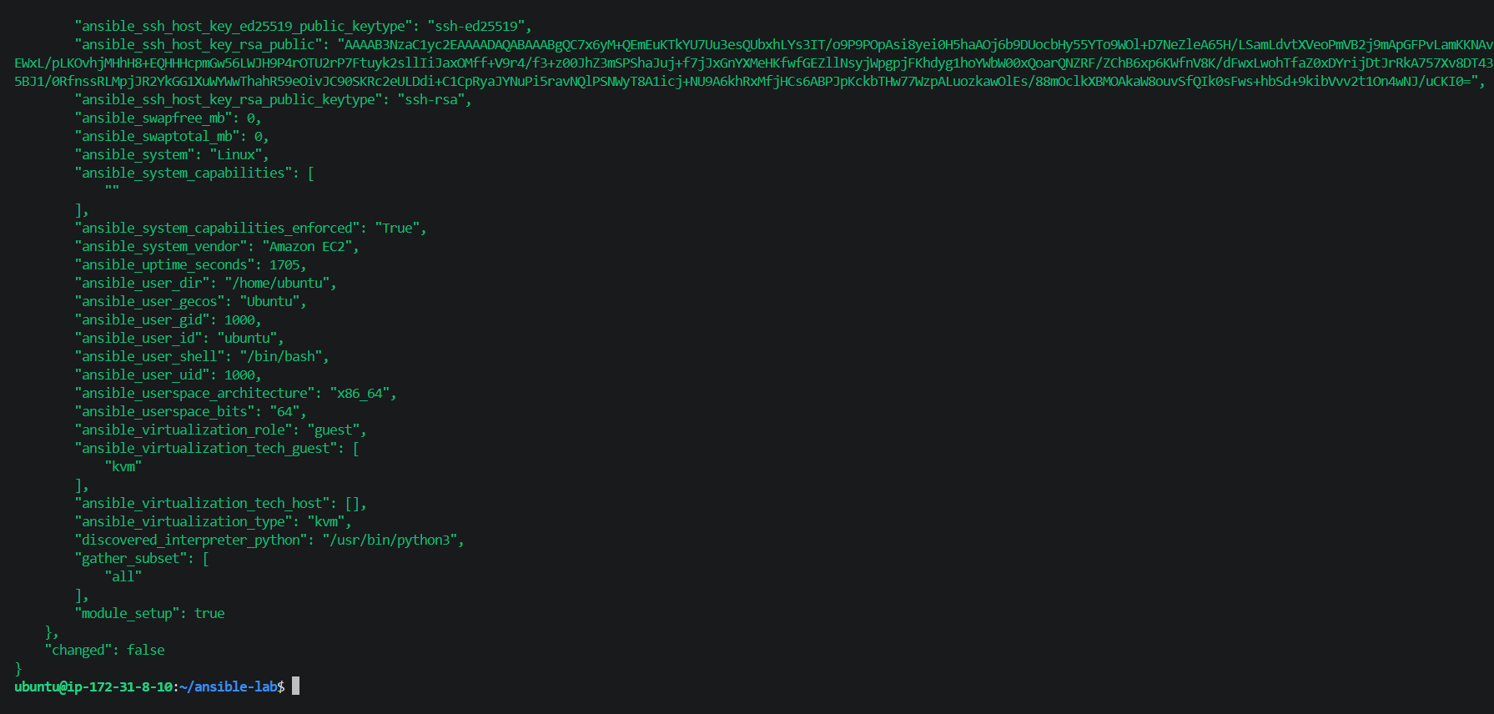
This displays system information, including operating system, network interfaces, memory and Python details. It generates a lot of output.
3. Check worker uptime
ansible all -i ansible_hosts -a "uptime"

4. Check available memory
ansible all -i ansible_hosts -a "free -m"

Step 5: Check whether the ansadm user exists
Run this on your Ansible master:
ansible all -i ansible_hosts -m shell -a "cat /etc/passwd | grep -i ansadm"
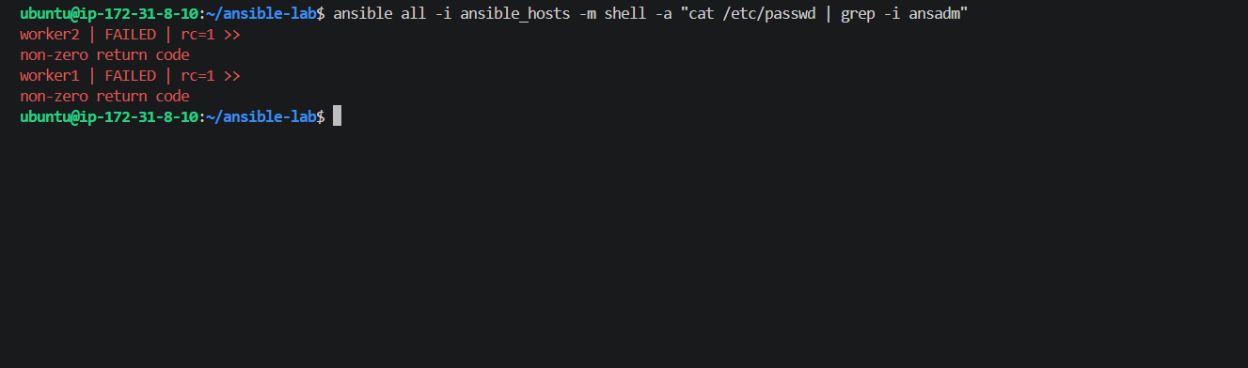
Step 6: Create a directory on both workers
Run this command on the Ansible master:
ansible all -i ansible_hosts -m file -a "path=/home/ubuntu/test state=directory mode=0755"
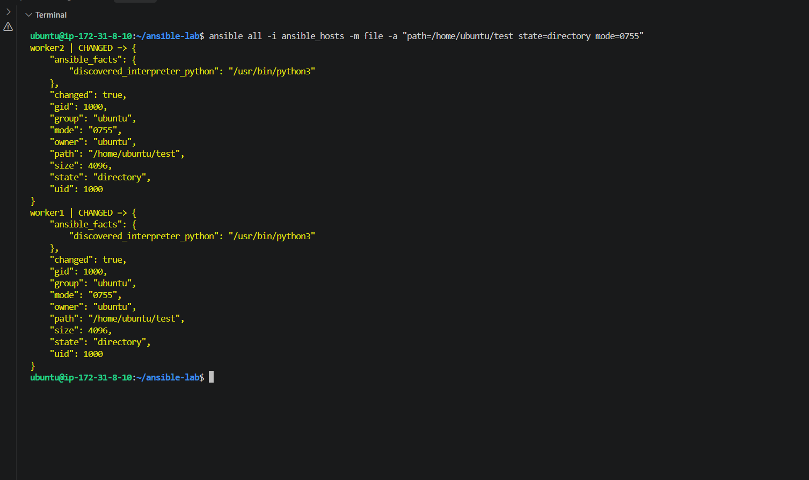
Step 7: Create the test group
Next, run:
ansible all -i ansible_hosts -m group -a "name=test state=present" -b
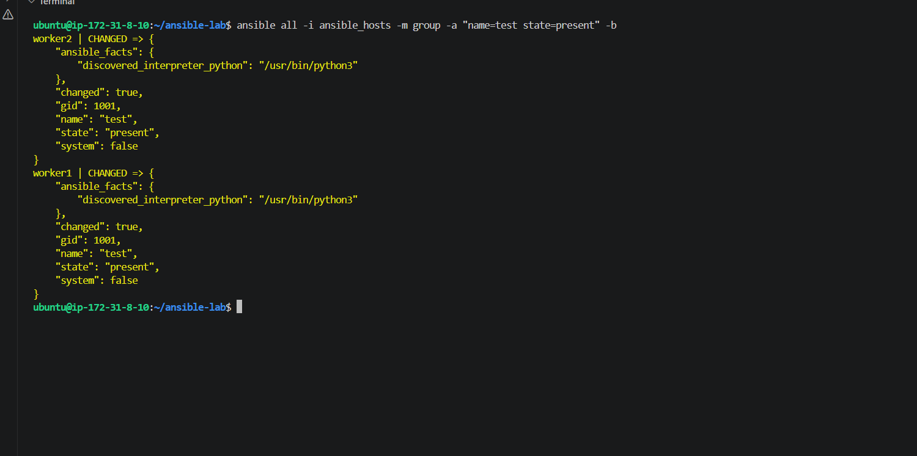
Next: Create a file with permissions 755
Run this command on your Ansible master:
ansible all -i ansible_hosts -m file -a "path=/home/ubuntu/testfile state=touch mode=0755"
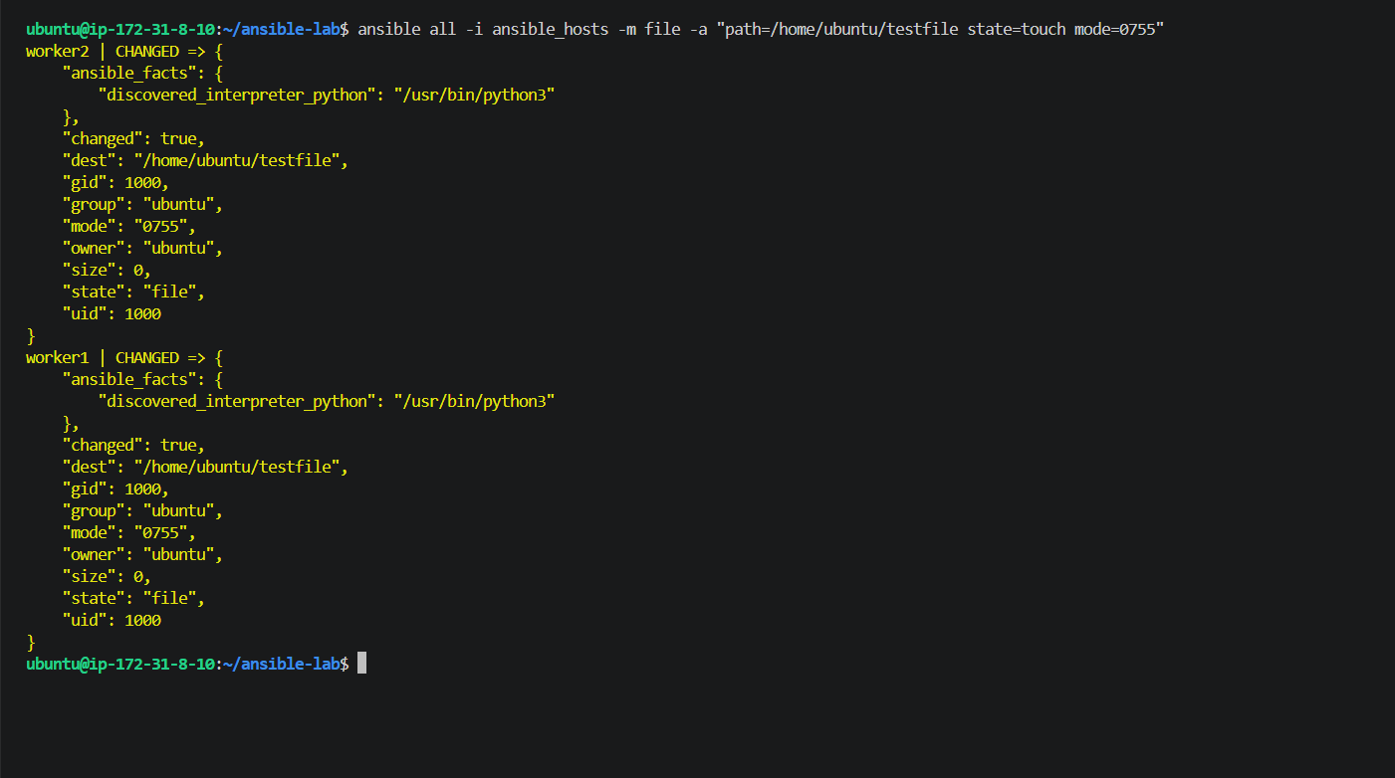
Next: Change file ownership
Your assignment includes changing ownership to the weblogic user and group. First, we need to check whether they exist on both workers.
Run this command on the master:
ansible all -i ansible_hosts -a "id weblogic"
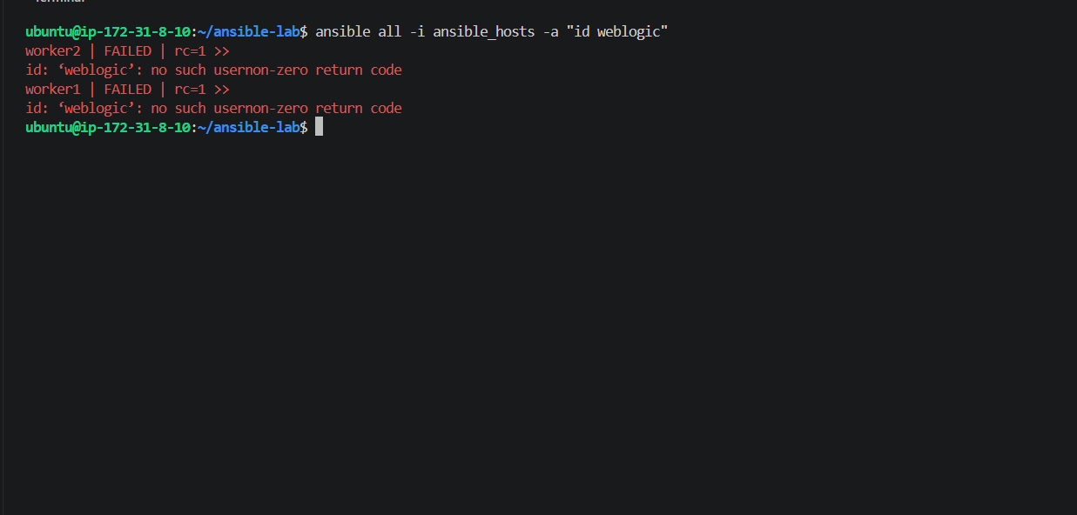
Step 1: Check whether the weblogic group exists
Run this command on your Ansible master:
ansible all -i ansible_hosts -m command -a "getent group weblogic"
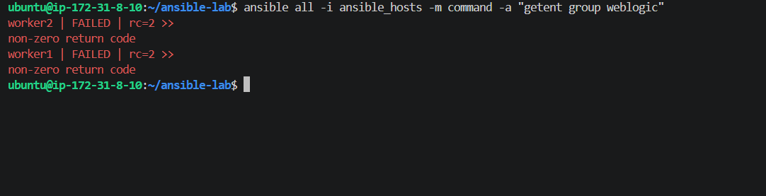
Step 2: Create the weblogic group
Run this command on your Ansible master:
ansible all -i ansible_hosts -m group -a "name=weblogic state=present" -b

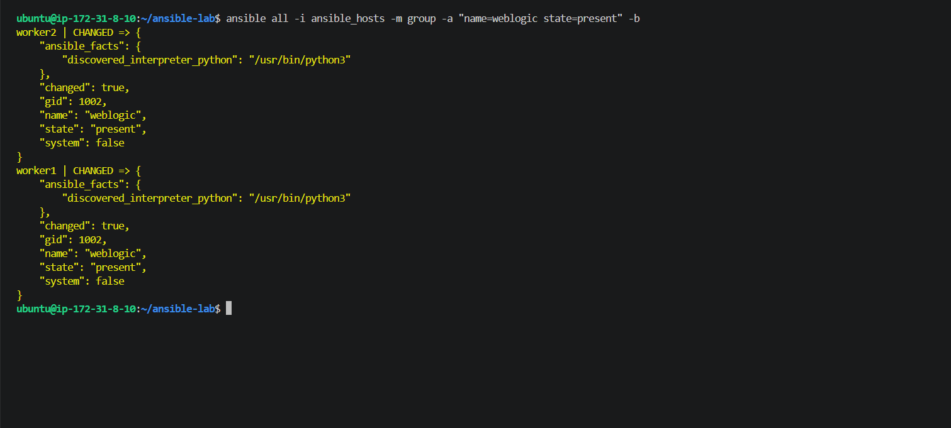
Step 3: Create the weblogic user
Run this command on your Ansible master:
ansible all -i ansible_hosts -m user -a "name=weblogic group=weblogic state=present" -b
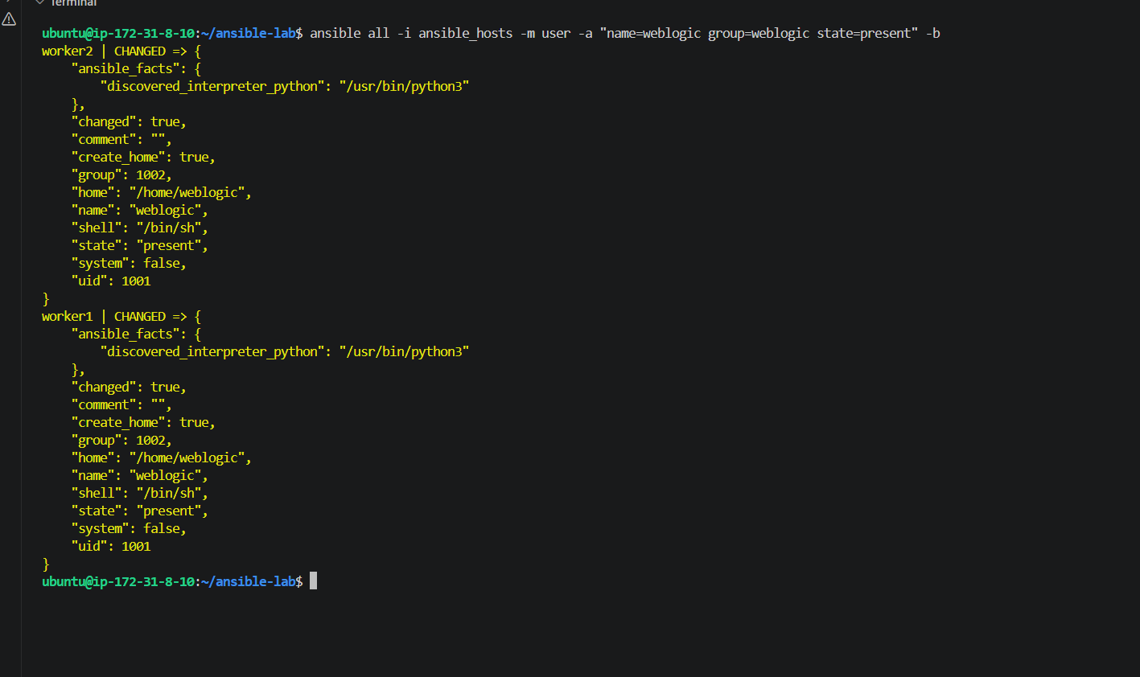
Step 4: Change file ownership
Now let's change the ownership of /home/ubuntu/testfile to weblogic, while keeping the file permissions unchanged.
Run this command on your Ansible master:
ansible all -i ansible_hosts -m file -a "path=/home/ubuntu/testfile owner=weblogic group=weblogic" -b
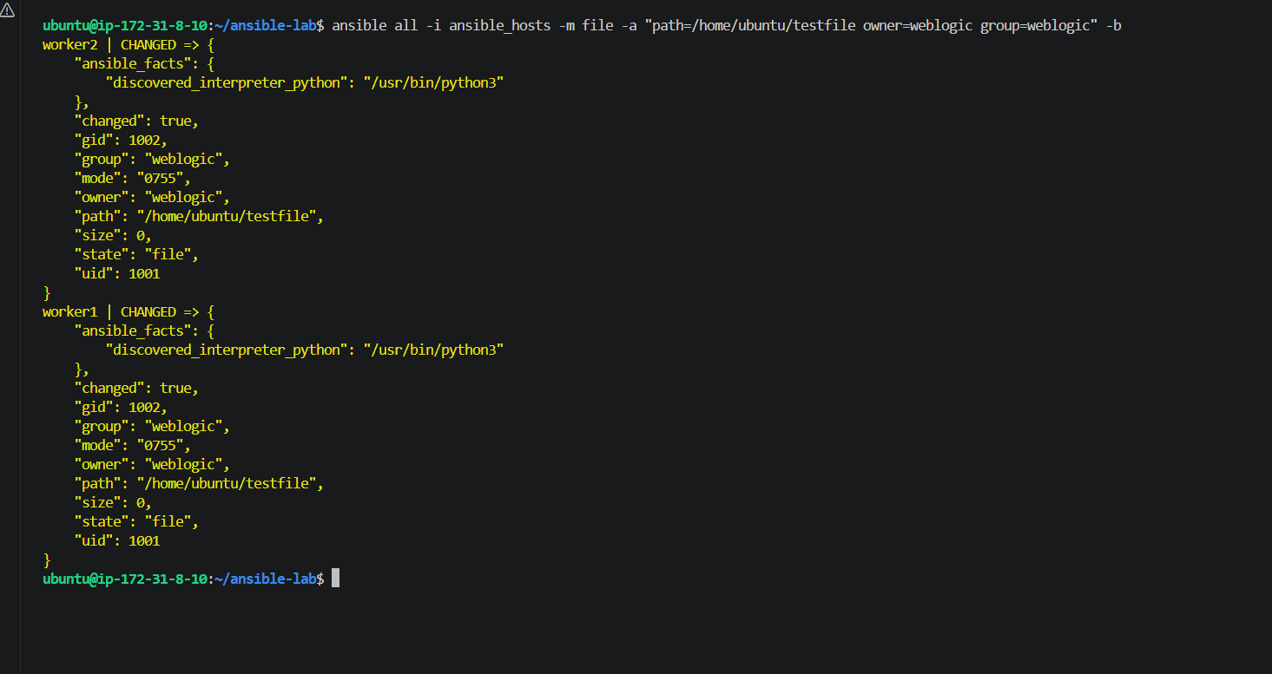
Step 5: Install Apache web server
Since your EC2 instances are running Ubuntu, we'll use apt and apache2 instead of the yum and httpd commands used on some Linux distributions.
Run this command on your Ansible master:
ansible all -i ansible_hosts -m apt -a "name=apache2 state=present update_cache=yes" -b
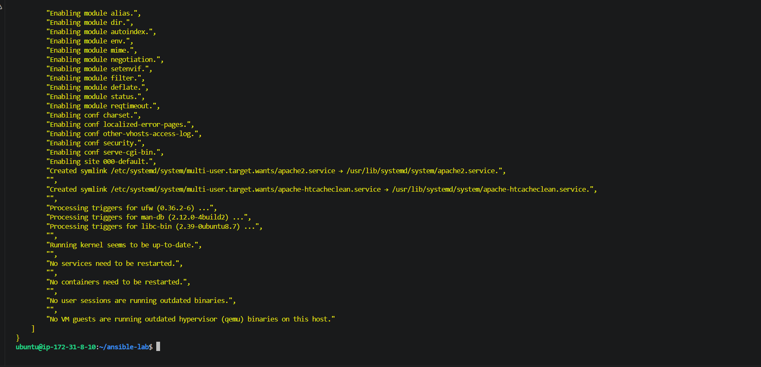
Step 6: Start Apache and enable it at boot
Run this command on your Ansible master:
ansible all -i ansible_hosts -m service -a "name=apache2 state=started enabled=yes" -b

Step 7: Verify Apache status
Run this command on the Ansible master:
ansible all -i ansible_hosts -m command -a "systemctl is-active apache2"
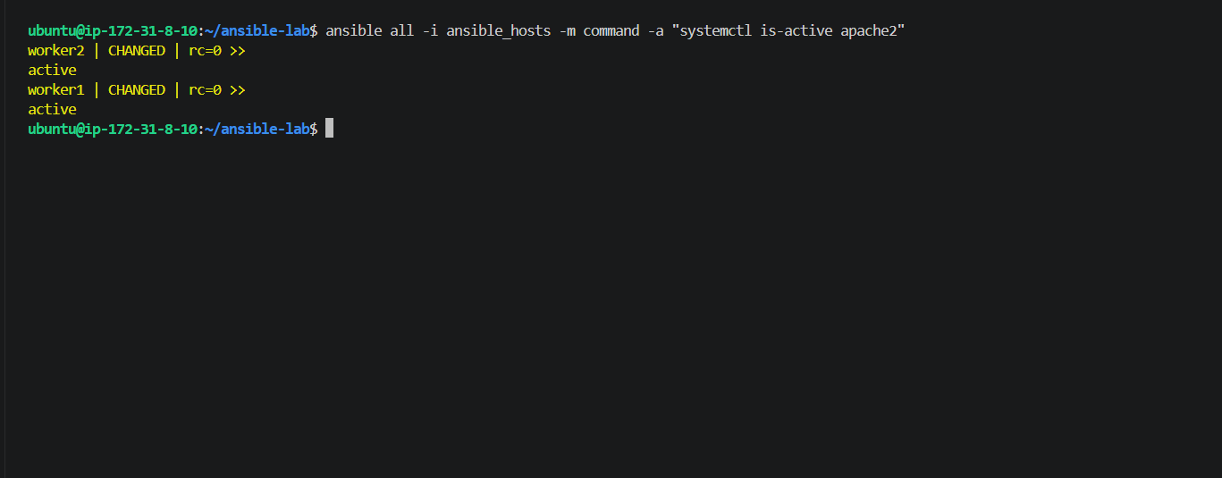
Step 8: Stop Apache on both workers
Now let's practice stopping a service using Ansible's service module.
Run this command on your Ansible master:
ansible all -i ansible_hosts -m service -a "name=apache2 state=stopped" -b

Step 9: Verify Apache is stopped
Run this command on your Ansible master:
ansible all -i ansible_hosts -m command -a "systemctl is-active apache2"
Next step: Let's verify the testfile ownership on both workers.
Run this command on the Ansible master:
ansible all -i ansible_hosts -m command -a "ls -l /home/ubuntu/testfile"
Run this command on your Ansible master:
ansible all -i ansible_hosts -m command -a "ls -l /home/ubuntu/testfile"
Run the command in your Ansible master terminal:
ansible all -i ansible_hosts -m command -a "ls -l /home/ubuntu/testfile"
Next step: Verify the Weblogic user
Run this command on your Ansible master:
ansible all -i ansible_hosts -m command -a "id weblogic"
Next step: Verify the Weblogic group
Run this command on your Ansible master:
ansible all -i ansible_hosts -m command -a "getent group weblogic"
Next step: Verify the test group
Earlier, we created a group named test. Let's verify it exists on both workers.
Run this command on your Ansible master:
ansible all -i ansible_hosts -m command -a "getent group test"
Next step: Check available disk space
Run this command on your Ansible master:
ansible all -i ansible_hosts -m command -a "df -h"
Next step: Check memory usage
Run this command on your Ansible master:
ansible all -i ansible_hosts -m command -a "free -h"
Next step: Check system uptime
Run this command on your Ansible master:
ansible all -i ansible_hosts -m command -a "uptime"
Step: Check worker uptime
Run this command on your Ansible master terminal:
ansible all -i ansible_hosts -m command -a "uptime"
Next step: Check the operating system
Run this command on your Ansible master:
ansible all -i ansible_hosts -m command -a "cat /etc/os-release"
Next step: Check the Apache package
Let's verify that Apache2 is installed on both workers, even though we stopped the service.
Run this command on your Ansible master:
ansible all -i ansible_hosts -m command -a "apache2 -v"
Next step: Check whether Apache is enabled at startup
Run this command on your Ansible master:
ansible all -i ansible_hosts -m command -a "systemctl is-enabled apache2"
Next step: Check the Ansible-managed worker connectivity
Run this command on your Ansible master:
ansible all -i ansible_hosts -m ping
Expected output on both worker1 and worker2:
SUCCESS => {
"changed": false,
"ping": "pong"
}
Next step: Verify the ansible version
Run this command on your Ansible master:
ansible --version
Next step: Check the inventory
Run this command from ~/ansible-lab:
ansible-inventory -i ansible_hosts --list

Next step: Verify the workers group
Run this command:
ansible workers -i ansible_hosts -m ping
